**Ujian Akhir Semester**

**WEB PROGRAMMING**

**Name: Martinus Grady Naftali**

**NIM: 2401962453**

**Class Program: LB08**

**Date:**

**6 Februari 2023**

**Lecturer:**

**Rani Puspita, S.Kom., M.Kom**

**UNIVERSITAS BINA NUSANTARA**

**COMPUTER SCIENCE**

**2022/2023**

# **Table of Content**

I. Project Link 4

II. Create Project 4

A. Composer Create Project 4

B. Change the directory 4

C. Run the project 4

III. Configure Database and Storage 5

A. Create New Database in phpMyAdmin using XAMPP 5

B. Create Laravel Storage 5

C. Add images to Storage 5

IV. Configure ENV 7

A. Change App Name 7

B. Change Database 7

C. Change Filesystem Driver 7

V. Create Models and migration 7

A. Publisher 7

B. Book 10

C. Category 12

D. BookCategory 14

E. Migrate 16

VI. Create Database Seeders 16

A. Publisher 16

B. Book 17

C. Category 19

D. BookCategory 20

E. Create Call to All Seeders 23

VII. Create Routing 24

A. Initialization 24

B. Home 24

C. Book Detail 24

D. Category 24

E. Publisher 24

F. Contact 25

G. Result 25

VIII. Create Controllers 26

A. Initialization 26

B. Home 26

1) Index 26

2) Category 26

3) View Book 27

4) Contact 27

5) Result 28

C. Publisher 29

1) Index 29

2) Publisher Detail 29

3) Result 30

IX. Create Views 30

A. Initialization 30

B. Import bootstrap 31

C. Layout 32

D. Components 34

E. Page Initialization 36

F. Home & Category 36

G. Book Detail 37

H. Contact 38

I. Publisher List 39

J. Publisher Detail 40

X. Screenshot 41

A. Home 41

B. Category 42

C. Book Detail 44

D. Publisher List 45

E. Publisher Detail 45

F. Contact 47

XI. Reference 48

A. Picture and Text 48

B. Documentation 48

# Project Link

llll

# Create Project

## Composer Create Project

Create a new laravel project by typing “composer create-project -–prefer-dist laravel/laravel=”^8.0" 2401962453_AmazingEGrocery” in the terminal and press enter.

I use -–prefer-dist laravel/laravel=”^8.0" to install a specific laravel version, which is version 8. “2401962453_AmazingEGrocery” is the name of the project.

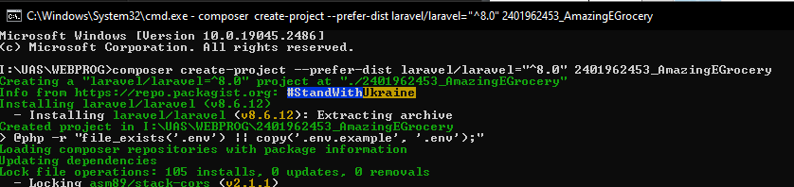

## Change the directory

Change directory to project folder using cd command.

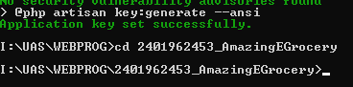

## Run the project

Run the project typing “php artisan serve” and then press enter.

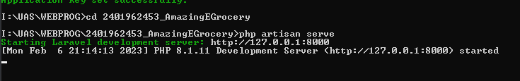

Then go to <http://127.0.0.1:8000/> in your browser.

# Configure Database and Storage

## Create New Database in phpMyAdmin using XAMPP

Open XAMPP and start Apache and MySQL.

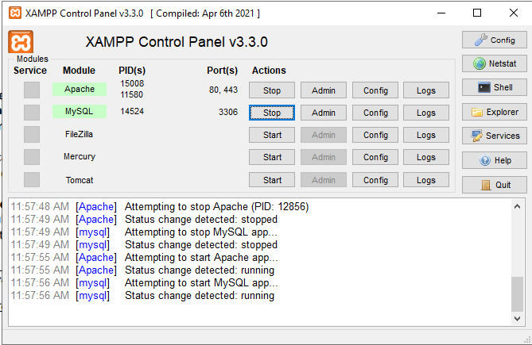

Go to MySQL admin and create new database named “giantbooksupplier”.

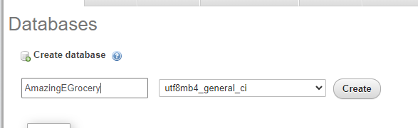

## Create Laravel Storage

Go to terminal and type “php artisan storage:link” to create new storage to store files.



## Add images

Create a new folder called item_image in public folder, go inside the new folder and add image there.

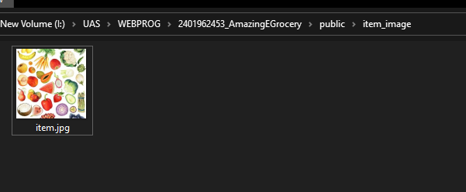

Create a new folder called “images” inside storage/app/public directory.

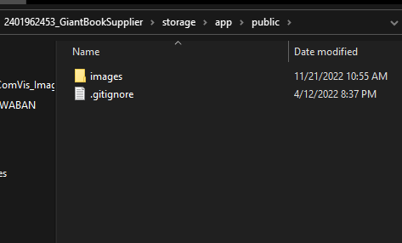

Inside images folder, create two new folders called book and publisher.

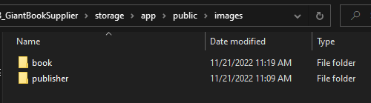

Inside book folder, fill it with book cover images.

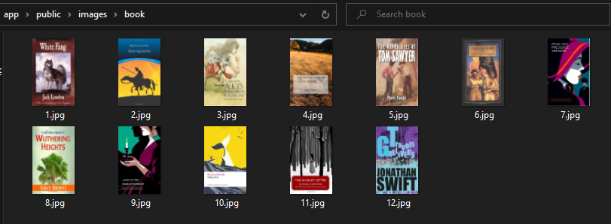

Inside publisher folder, fill it with publisher logo images.

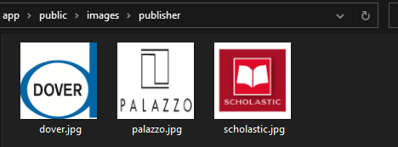

# Configure ENV

## Change App Name

Inside the .env file in the root directory of the project, change the “APP_NAME” into “Amazing E-Grocery”.

APP_NAME=Amazing E-Grocery

APP_ENV=local

APP_KEY=base64:DAh+XUvsovqGP1U4hBd7Pe7El4YjSDfA2RVofXwtyN8=

APP_DEBUG=true

APP_URL=http://localhost

## Change Database

Once again, inside the .env file in the root directory of the project, change the “DB_DATABASE” into “amazingegrocery”.

DB_CONNECTION=mysql

DB_HOST=127.0.0.1

DB_PORT=3306

DB_DATABASE=amazingegrocery

DB_USERNAME=root

DB_PASSWORD=

## Change Filesystem Driver

Finally, inside the .env file in the root directory of the project, change the “FILESYSTEM_DRIVER” into “public”.

BROADCAST_DRIVER=log

CACHE_DRIVER=file

FILESYSTEM_DRIVER=public

QUEUE_CONNECTION=sync

SESSION_DRIVER=file

SESSION_LIFETIME=120

# Create Models and migration

## Role

Go to the terminal and type “php artisan make:model Role –migration” to create Role model and the migration.



Go to database/migrations folder and go to create_roles_table file.

In the public function up(), implement Schema∷create to create table fields which later be migrated to the database. Add increments(‘role_id’) (which automatically assigned by laravel as PK and as an int that is auto incremented), and role_name (varchar(10)). I also set all the attributes to nullable(false) so that they are set as “not null”.

class CreateRolesTable extends Migration

{

*/\*\**

*\* Run the migrations.*

*\**

*\* @return void*

*\*/*

    public function up()

    {

        Schema::create('roles', function (Blueprint $table) {

            $table->increments('role_id')->nullable(false);

            $table->string('role_name', 10)->nullable(false);

        });

    }

*/\*\**

*\* Reverse the migrations.*

*\**

*\* @return void*

*\*/*

    public function down()

    {

        Schema::dropIfExists('roles');

    }

}

Go to Role model in app/Models folder and fill the Role class with table, fillable and function for table relationship.

class Role extends Model

{

    use HasFactory;

public $timestamps = false;

    protected $table = 'roles';

    protected $fillable = [

        'role_name'

    ];

    public function account()

    {

        return $this->hasOne(Account::class,

        'role_id', 'role_id');

    }

}

Set table to ‘roles’ and timestamps to false

protected $table = 'roles';

Add fillable table fields to fillable.

    protected $fillable = [

        'role_name'

    ];

Add account function to add table relationship to acount table (one to one) using hasOne method by referencing acount ‘role_id’ to role ‘role_id’.

    public function account()

    {

        return $this->hasOne(Account::class,

        'role_id', 'role_id');

    }

## Gender

Go to the terminal and type “php artisan make:model Gender –migration” to create Gender model and the migration.

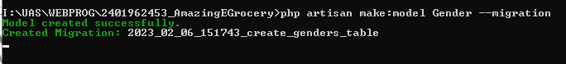

Go to database/migrations folder and go to create_genders_table file.

class CreateGendersTable extends Migration

{

*/\*\**

*\* Run the migrations.*

*\**

*\* @return void*

*\*/*

    public function up()

    {

        Schema::create('genders', function (Blueprint $table) {

            $table->increments('gender_id')->nullable(false);

            $table->string('gender_desc', 10)->nullable(false);

        });

    }

*/\*\**

*\* Reverse the migrations.*

*\**

*\* @return void*

*\*/*

    public function down()

    {

        Schema::dropIfExists('genders');

    }

}

In the public function up(), implement Schema∷create to create table fields which later be migrated to the database. Add increments(‘gender_id’) (which automatically assigned by laravel as PK and as an int that is auto incremented), and gender_desc (varchar(10)). I also set all the attributes to nullable(false) so that they are set as “not null”.

Go to Gender model in app/Models folder and fill the Gender class with table, fillable and function for table relationship.

class Gender extends Model

{

    use HasFactory;

public $timestamps = false;

    protected $table = 'genders';

    protected $fillable = [

        'gender_desc'

    ];

    public function account()

    {

        return $this->hasOne(Account::class,

        'gender_id', 'gender_id');

    }

}

Set table to ‘genders’ ande timestamps to false

 protected $table = 'genders';

Add fillable table fields to fillable.

protected $fillable = [

        'gender_desc'

    ];

Add account function to add table relationship to acount table (one to one) using hasOne method by referencing acount ‘gender_id’ to role ‘gender_id’.

    public function account()

    {

        return $this->hasOne(Account::class,

        'gender_id', 'gender_id');

    }

## Account

Go to the terminal and type “php artisan make:model Account –migration” to create Account model and the migration.

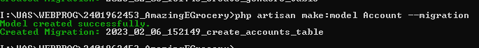

Go to database/migrations folder and go to create_accounts_table file.

class CreateAccountsTable extends Migration

{

*/\*\**

*\* Run the migrations.*

*\**

*\* @return void*

*\*/*

    public function up()

    {

        Schema::create('accounts', function (Blueprint $table) {

            $table->increments('account_id')->nullable(false);

            $table->foreignId('role_id')->reference('role_id')->on('roles')->onUpdate('cascade')->onDelete('cascade');

            $table->foreignId('gender_id')->reference('gender_id')->on('genders')->onUpdate('cascade')->onDelete('cascade');

            $table->string('first_name', 25)->nullable(false);

            $table->string('last_name', 25)->nullable(false);

            $table->string('email', 100)->nullable(false);

            $table->string('display_picture_link', 100)->nullable(false);

            $table->string('password');

            $table->rememberToken();

            $table->timestamps();

        });

    }

*/\*\**

*\* Reverse the migrations.*

*\**

*\* @return void*

*\*/*

    public function down()

    {

        Schema::dropIfExists('accounts');

    }

}

In the public function up(), implement Schema∷create to create table fields which later be migrated to the database. Add increments(‘acount_id’) (which automatically assigned by laravel as PK and as an int that is auto incremented), role_id, gender_id (foreignId which reference the id on role and gender table, and add cascade so when parent record is updated or deleted, the child record will also be updated or deleted), first_name (varchar(25)), last_name (varchar(25)), email (varchar(100)), display_picture_link (varchar(100)), password, rememberToken, and timestamp. I also set all the attributes to nullable(false) so that they are set as “not null”.

Go to Account model in app/Models folder and fill the Account class with table, fillable and function for table relationship.

class Account extends Model

{

    use HasFactory;

    protected $table = 'accounts';

    protected $fillable = [

        'role_id',

        'gender_id',

        'first_name',

        'last_name',

        'email',

        'display_picture_link',

        'password'

    ];

    public function role()

    {

        return $this->belongsTo(Role::class, 'role_id', 'role_id');

    }

    public function gender()

    {

        return $this->belongsTo(Gender::class, 'gender_id', 'gender_id');

    }

}

Set table to ‘account’.

protected $table = 'accounts';

Add fillable table fields to fillable.

    protected $fillable = [

        'role_id',

        'gender_id',

        'first_name',

        'last_name',

        'email',

        'display_picture_link',

        'password'

    ];

Add role function to add table relationship to roles table (acount is own by one role) using belongsTo method by referencing role ‘role_id’ to account ‘role_id’.

    public function role()

    {

        return $this->belongsTo(Role::class, 'role_id', 'role_id');

    }

Add gender function to add table relationship to roles table (acount is own by one gender) using belongsTo method by referencing gender ‘gender_id’ to account ‘gender_id’.

    public function gender()

    {

        return $this->belongsTo(Gender::class, 'gender_id', 'gender_id');

    }

Add orders function to add table relationship to roles table (acount has many orders) using hasMany method by referencing order ‘acount_id’ to account ‘account_id’.

    public function orders()

    {

        return $this->hasMany(Order::class, 'account_id', 'account_id');

    }

## Item

Go to the terminal and type “php artisan make:model Item –migration” to create Item model and the migration.

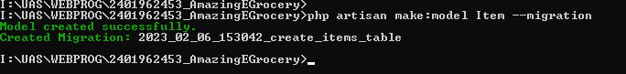  
Go to database/migrations folder and go to create_items_table file.

class CreateItemsTable extends Migration

{

*/\*\**

*\* Run the migrations.*

*\**

*\* @return void*

*\*/*

    public function up()

    {

        Schema::create('items', function (Blueprint $table) {

            $table->increments('item_id')->nullable(false);

            $table->string('item_name', 50)->nullable(false);

            $table->text('item_desc', 500)->nullable(false);

            $table->integer('price')->nullable(false);

        });

    }

*/\*\**

*\* Reverse the migrations.*

*\**

*\* @return void*

*\*/*

    public function down()

    {

        Schema::dropIfExists('items');

    }

}

In the public function up(), implement Schema∷create to create table fields which later be migrated to the database. Add increments(‘item_id’) (which automatically assigned by laravel as PK and as an int that is auto incremented), item_name (varchar(50)), item_desc (varchar only support up to 255 characters, so I use text which supports more than 255 characters (500), and price(int). I also set all the attributes to nullable(false) so that they are set as “not null”.

Go to Item model in app/Models folder and fill the Item class with table, fillable and function for table relationship.

class Item extends Model

{

    use HasFactory;

public $timestamps = false;

    protected $table = 'items';

    protected $fillable = [

        'item_name',

        'item_desc',

        'price'

    ];

    public function order()

    {

        return $this->hasOne(Role::class, 'item_id', 'item_id');

    }

}

Set table to ‘items’, timestamps to false and add fillable table fields to fillable

    protected $fillable = [

        'item_name',

        'item_desc',

        'price'

    ];

Add order function to add table relationship to order table (one to one) using hasOne method by referencing order ‘item_id’ to item ‘item_id’.

    public function order()

    {

        return $this->hasOne(Role::class, 'item_id', 'item_id');

    }

## Order

Go to the terminal and type “php artisan make:model Order –migration” to create Item model and the migration.

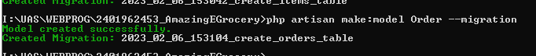  
Go to database/migrations folder and go to create_orders_table file.

class CreateOrdersTable extends Migration

{

*/\*\**

*\* Run the migrations.*

*\**

*\* @return void*

*\*/*

    public function up()

    {

        Schema::create('orders', function (Blueprint $table) {

            $table->increments('order_id')->nullable(false);

            $table->foreignId('account_id')->reference('account_id')->on('accounts')->onUpdate('cascade')->onDelete('cascade');

            $table->foreignId('item_id')->reference('item_id')->on('items')->onUpdate('cascade')->onDelete('cascade');

            $table->integer('price')->nullable(false);

        });

    }

*/\*\**

*\* Reverse the migrations.*

*\**

*\* @return void*

*\*/*

    public function down()

    {

        Schema::dropIfExists('orders');

    }

}

In the public function up(), implement Schema∷create to create table fields which later be migrated to the database. Add increments(‘order_id’) (which automatically assigned by laravel as PK and as an int that is auto incremented), account_id, item_id (foreignId which reference the id on account and item table, and add cascade so when parent record is updated or deleted, the child record will also be updated or deleted), and price (int). I also set all the attributes to nullable(false) so that they are set as “not null”.

Go to Order model in app/Models folder and fill the Order class with table, fillable and function for table relationship.

class Order extends Model

{

    use HasFactory;

public $timestamps = false;

    protected $table = 'orders';

    protected $fillable = [

        'account_id',

        'item_id',

        'price'

    ];

    public function account()

    {

        return $this->belongsTo(Account::class, 'account_id', 'account_id');

    }

    public function items()

    {

        return $this->belongsTo(Item::class, 'item_id', 'item_id');

    }

}

Set table to ‘orders’, timestamps to false, and add fillable table fields to fillable

protected $table = 'orders';

    protected $fillable = [

        'account_id',

        'item_id',

        'price'

    ];

Add account function to add table relationship to accounts table (order is own by one account) using belongsTo method by referencing order ‘account_id’ to account ‘account_id’.

    public function account()

    {

        return $this->belongsTo(Account::class, 'account_id', 'account_id');

    }

Add items function to add table relationship to items table (order is own by many item) using belongsTo method by referencing order ‘item_id’ to item ‘item_id’.

    public function items()

    {

        return $this->belongsTo(Item::class, 'item_id', 'item_id');

    }

## Migrate

Type ‘php artisan migrate:fresh’ in the terminal and enter to migrate to the database

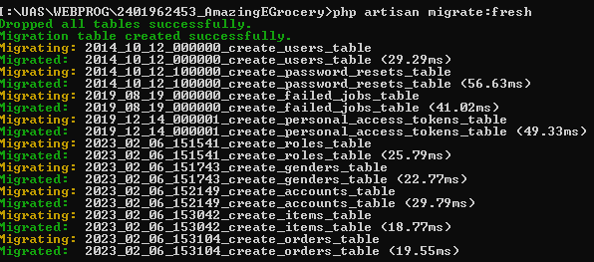

Tables are successfully migrated to the database

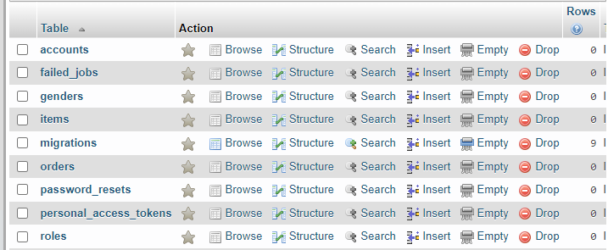

# Create Database Seeders

## Item

Go to terminal and type ‘php artisan make:seeder ItemSeeder’ to make item seeder.



Go to ItemSeeder in database/seeders folder and add use App\Models\Item after use Illuminate\Database\Seeder.

use App\Models\Item;

In the public function run() by referencing the Item model, call firstOrCreate method to create a new record if the record is not yet created. Pass fillable fields value such as item_name, item_desc, and price from data you have collected in an array as an argument in firtsOrCreate method.

class ItemSeeder extends Seeder

{

*/\*\**

*\* Run the database seeds.*

*\**

*\* @return void*

*\*/*

    public function run()

    {

        Item::firstOrCreate([

            'item_name' => "Kailan Baby Conventional",

            'item_desc' => "Baby Kailan adalah sayuran berdaun tebal, datar, mengkilap dan berwarna hijau dengan batang tebal. Tahukah kamu bahwa sayur kailan memiliki kandungan nutrisi yang cukup lengkap bagi tubuh.",

            'price'=> 15800

        ]);

        Item::firstOrCreate([

            'item_name' => "Pakchoy Pakcoy",

            'item_desc' => "Buah yang kami kirim setiap harinya, sehingga, sayur yang baru dipanen akan dikirim setiap harinya waktu dini hari. Setelah datang, kami bersihkan dan siapkan untuk dikirimkan ke pelanggan.",

            'price'=> 2400

        ]);

        Item::firstOrCreate([

            'item_name' => "Selada Keriting",

            'item_desc' => "Daun selada adalah sumber vitamin A dan vitamin K yang sangat tinggi. Selain itu, daun selada juga mengandung berbagai nutrisi penting seperti zat besi, kalium, kalsium, folat, dan serat.",

            'price'=> 8100

        ]);

    }

}

## Gender

Go to terminal and type ‘php artisan make:seeder GenderSeeder’ to make gender seeder.



Go to GenderSeeder in database/seeders folder and add use App\Models\Gender after use Illuminate\Database\Seeder.

use App\Models\Gender;

In the public function run() by referencing the Item model, call firstOrCreate method to create a new record if the record is not yet created. Pass fillable fields value such as gender_desc from data you have collected in an array as an argument in firtsOrCreate method.

class GenderSeeder extends Seeder

{

*/\*\**

*\* Run the database seeds.*

*\**

*\* @return void*

*\*/*

    public function run()

    {

        Gender::firstOrCreate([

            'gender_desc' => "Male",

        ]);

        Gender::firstOrCreate([

            'gender_desc' => "Female",

        ]);

    }

}

## Role

Go to terminal and type ‘php artisan make:seeder RoleSeeder’ to make role seeder.



Go to RoleSeeder in database/seeders folder and add use App\Models\Role after use Illuminate\Database\Seeder.

use App\Models\Role;

In the public function run() by referencing the Role model, call firstOrCreate method to create a new record if the record is not yet created. Pass fillable fields value such as role_name from data you have collected in an array as an argument in firtsOrCreate method.

class RoleSeeder extends Seeder

{

*/\*\**

*\* Run the database seeds.*

*\**

*\* @return void*

*\*/*

    public function run()

    {

        Role::firstOrCreate([

            'role_name' => "User",

        ]);

        Role::firstOrCreate([

            'role_name' => "Admin",

        ]);

    }

}

## Account

Go to terminal and type ‘php artisan make:seeder AccountSeeder’ to make role seeder.



Go to AccountSeeder in database/seeders folder and add use App\Models\Account after use Illuminate\Database\Seeder.

use App\Models\Account;

In the public function run() by referencing the Role model, call firstOrCreate method to create a new record if the record is not yet created. Pass fillable fields value such as role_name from data you have collected in an array as an argument in firtsOrCreate method.

## Create Call to All Seeders

To call all the seeders we have created, go to database/seeders folder and go to DatabaseSeeder.php. Inside that file, in the public function run() use method call and reference it to all seeders we have created.

class DatabaseSeeder extends Seeder

{

*/\*\**

*\* Seed the application's database.*

*\**

*\* @return void*

*\*/*

    public function run()

    {

        $this->call(ItemSeeder::class);

        $this->call(GenderSeeder::class);

        $this->call(RoleSeeder::class);

        $this->call(AccountSeeder::class);

    }

}

Go to terminal and type “php artisan db:seed” to seed all of our data to the database

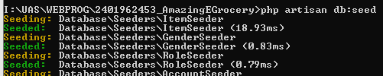

# Create Index

## Install Laravel UI

Type “composer require laravel/ui:*” in terminal

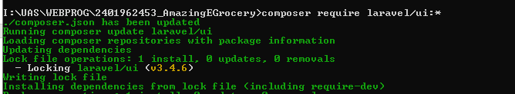

Type “php artisan ui bootstrap –auth” in terminal

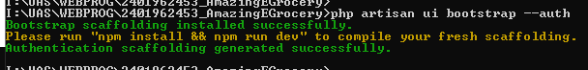

Type “npm install && npm run dev” in terminal

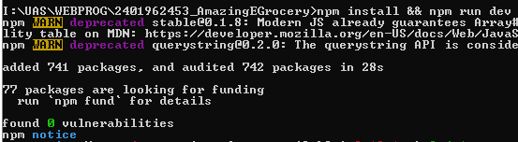

## Import bootstrap

Go to bootstrap website, <https://cdn.jsdelivr.net/npm/bootstrap@5.2.3/dist/js/bootstrap.bundle.min.js/>

<https://cdn.jsdelivr.net/npm/bootstrap@5.2.3/dist/css/bootstrap.min.css/>

Then copy all the css and js code.

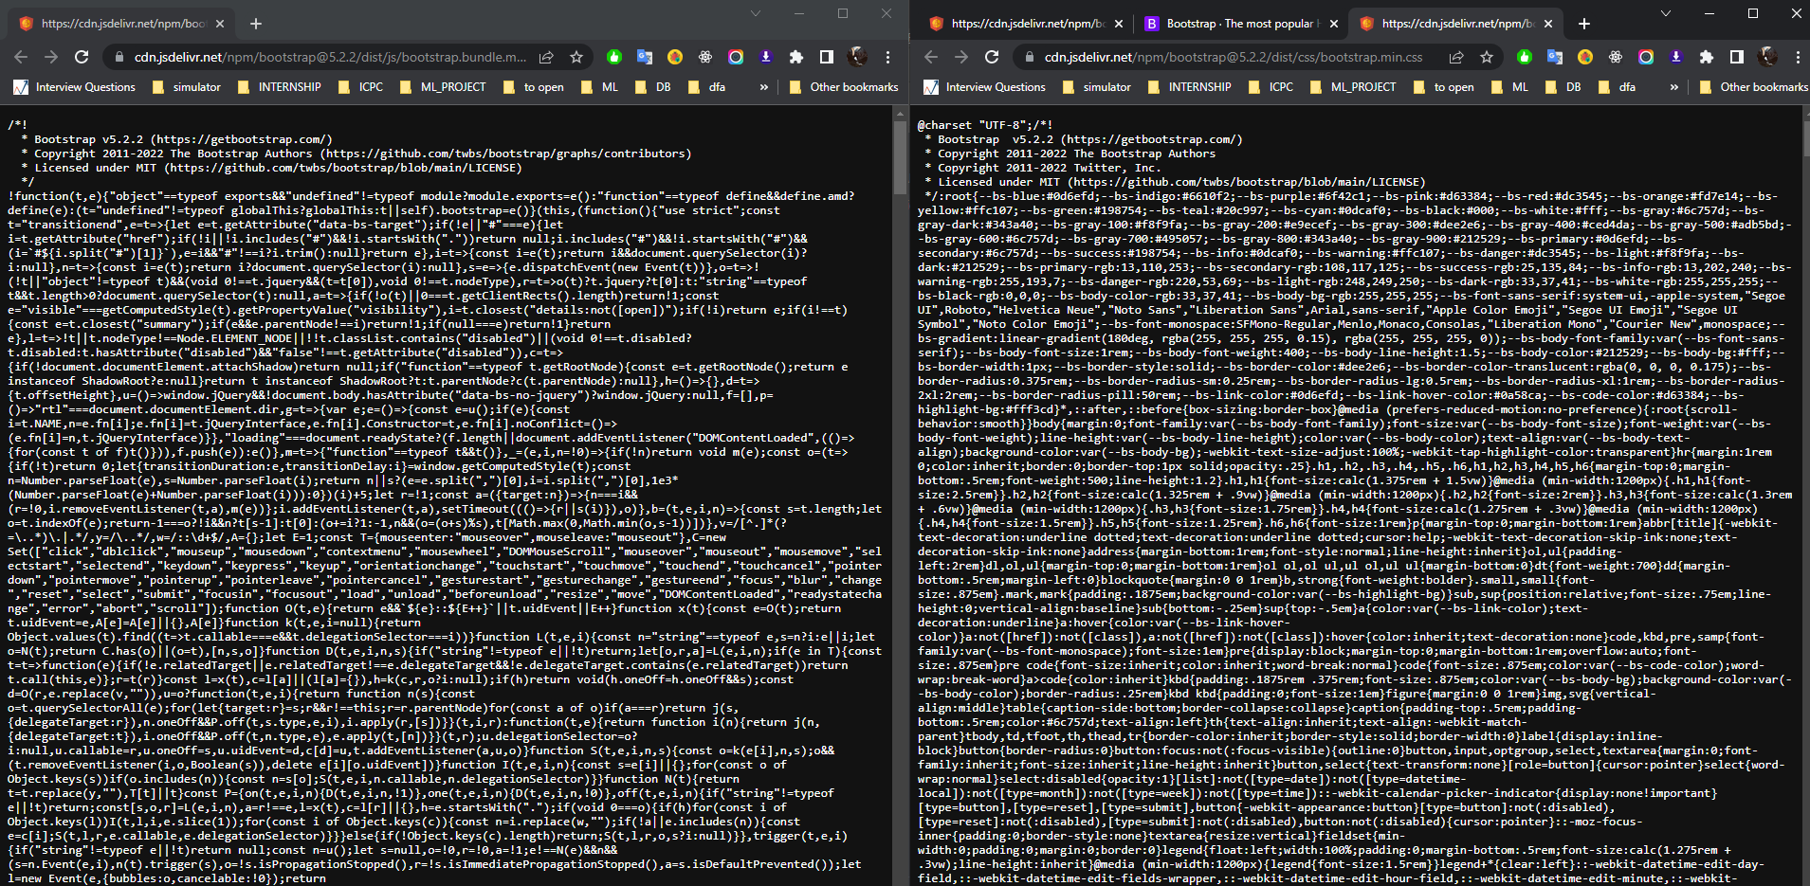

Put the css code to public/css/bootstrap.css and js code to public/js/bootstrap.bundle.min.js

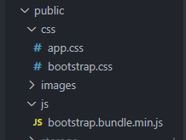

Import css.bootstrap.css in head and js/bootstrap.bundle.min.js script in body at views/layouts/app.blade.php

<head>

    <meta charset="utf-8">

    <meta name="viewport" content="width=device-width, initial-scale=1">

*<!-- CSRF Token -->*

    <meta name="csrf-token" content="{{ csrf_token() }}">

    <title>{{ config('app.name', 'Laravel') }}</title>

*<!-- Scripts -->*

    <script src="{{ asset('js/app.js') }}" defer></script>

*<!-- Fonts -->*

    <link rel="dns-prefetch" href="//fonts.gstatic.com">

    <link href="https://fonts.googleapis.com/css?family=Nunito" rel="stylesheet">

*<!-- Styles -->*

    <link href="{{ asset('css/app.css') }}" rel="stylesheet">

    <link href="{{ asset('css/bootstrap.css') }}" rel="stylesheet">

</head>

*<!-- Scripts -->*

    <script src="{{ asset('js/bootstrap.bundle.min.js') }}"></script>

</body>

</html>

## Customize app.blade.php

Add footer below main.

        <main class="py-4">

            @yield('content')

        </main>

        <footer class="footer" style="position: absolute; bottom: 0; width: 100%; background-color: #adead2">

            <div class="text-center p-4">

                © Amazing E-Grocery 2023

            </div>

        </footer>

Customize the navbar.

## Customize index.blade.php

Change welcome.blade.php into index.blade.php

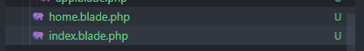

Follow the code below to add bootstrap component and other element in index

@section('content')

<div class="container">

    <div class="row justify-content-center">

        <div class="d-flex col-md-8 justify-content-center align-items-center">

            <div class="d-flex justify-content-center align-items-center rounded-circle bg-white" style="width: 500px; height: 500px; border: 12px solid #f5da55;">

                <h1 class="text-center">{{__('index.title')}}</h5>

            </div>

        </div>

    </div>

</div>

@endsection

# Create Register

## Change Register View

Open resources/views/auth/register.blade.php. Then follow the following code with bootstrap component and other elements

    @extends('layouts.app')

    @section('content')

        <div class="container">

            <div class="row justify-content-center">

                <div class="col-md-12">

                    <form method="POST" action="{{ route('register') }}" id="registration_form"">

                        @csrf

                        <div class="form-group mb-4">

                            <h3 class="text-left"><u>{{ __('form.titleRegister') }}</u></h3>

                        </div>

                        <div class="form-group d-flex justify-content-between">

                            <div class="col-6 pe-2">

                                <div class="form-group row mb-2">

                                    <label for="firstName" class="col-sm-3 col-form-label">{{ __('form.first_name') }} :</label>

                                    <div class="col-sm-9">

                                        <input type="text" class="form-control" @error('first_name') is-invalid @enderror"

                                            id="firstName" name="firstName">

                                    </div>

                                    <span class="invalid-feedback" role="alert">

                                        @error('first_name')

                                            {{ $message }}

                                        @enderror

                                    </span>

                                </div>

                                <div class="form-group row mb-2">

                                    <label for="email" class="col-sm-3 col-form-label">{{ __('form.email') }} :</label>

                                    <div class="col-sm-9">

                                        <input type="email" class="form-control" @error('email') is-invalid @enderror"

                                            id="email" name="email">

                                    </div>

                                    <span class="invalid-feedback" role="alert">

                                        @error('email')

                                            {{ $message }}

                                        @enderror

                                    </span>

                                </div>

                                <div class="form-group row mb-2">

                                    <label for="gender" class="col-sm-3 col-form-label">{{ __('form.gender') }} :</label>

                                    <div class="col-sm-9 d-flex align-items-center">

                                        <div class="input-group-prepend @error('gender') is-invalid @enderror">

                                            <div class="form-check form-check-inline">

                                                <input class="form-check-input" type="radio" name="gender" id="male"

                                                    value="male">

                                                <label class="form-check-label" for="male">@lang('form.male')</label>

                                            </div>

                                            <div class="form-check form-check-inline">

                                                <input class="form-check-input" type="radio" name="gender" id="female"

                                                    value="female">

                                                <label class="form-check-label" for="female">@lang('form.female')</label>

                                            </div>

                                        </div>

                                    </div>

                                    <span class="invalid-feedback" role="alert">

                                        @error('gender')

                                            {{ $message }}

                                        @enderror

                                    </span>

                                </div>

                                <div class="form-group row mb-2">

                                    <label for="password" class="col-sm-3 col-form-label">{{ __('form.password') }} :</label>

                                    <div class="col-sm-9">

                                        <input type="password" class="form-control" @error('password') is-invalid @enderror"

                                            id="password" name="password">

                                    </div>

                                    <span class="invalid-feedback" role="alert">

                                        @error('password')

                                            {{ $message }}

                                        @enderror

                                    </span>

                                </div>

                            </div>

                            <div class="col-6 ps-2">

                                <div class="form-group row mb-2">

                                    <label for="lastName" class="col-sm-3 col-form-label">{{ __('form.last_name') }} :</label>

                                    <div class="col-sm-9">

                                        <input type="text" class="form-control" @error('lastName') is-invalid @enderror"

                                            id="lastName" name="lastName">

                                    </div>

                                    <span class="invalid-feedback" role="alert">

                                        @error('lastName')

                                            {{ $message }}

                                        @enderror

                                    </span>

                                </div>

                                <div class="form-group row mb-2">

                                    <label for="role" class="col-sm-3 col-form-label">{{ __('form.role') }} :</label>

                                    <div class="col-sm-9">

                                        <div class="input-group @error('role') is-invalid @enderror">

                                            <select class="form-control" id="role" form="registration_form" name="role">

                                                <option value="admin">@lang('form.admin')</option>

                                                <option value="user">@lang('form.user')</option>

                                            </select>

                                        </div>

                                    </div>

                                    <span class="invalid-feedback" role="alert">

                                        @error('role')

                                            {{ $message }}

                                        @enderror

                                    </span>

                                </div>

                                <div class="form-group row mb-2">

                                    <label for="displayPicture"

                                        class="col-sm-3 col-form-label">{{ __('form.display_picture') }} :</label>

                                    <div class="col-sm-9 d-flex align-items-center">

                                        <input type="file" class="form-control-file" id="displayPicture"

                                            name="displayPicture">

                                        <span class="text-danger">

                                    </div>

                                    <span class="invalid-feedback" role="alert">

                                        @error('displayPicture')

                                            {{ $message }}

                                        @enderror

                                    </span>

                                </div>

                                <div class="form-group row mb-2">

                                    <label for="confirmPassword" class="col-sm-3 col-form-label">{{ __('form.confirm_password') }} :</label>

                                    <div class="col-sm-9">

                                        <input type="password" class="form-control" @error('confirmPassword') is-invalid @enderror"

                                            id="confirmPassword" name="confirmPassword">

                                    </div>

                                    <span class="invalid-feedback" role="alert">

                                        @error('confirmPassword')

                                            {{ $message }}

                                        @enderror

                                    </span>

                                </div>

                            </div>

                        </div>

                    </form>

                </div>

            </div>

        </div>

    @endsection

## Change Auth

Change user model in config/auth.php into Account∷class

    'providers' => [

        'users' => [

            'driver' => 'eloquent',

            'model' => App\Models\Account::class,

        ],

# Create Login

# Create Profile

# Create Home Page

# Create Cart Menu

# Create Account Maintenance

# Create Change Role

# Create Localization

# Create Middleware

## Initialization

Go to web.php file in routes folder and import HomeController and PublisherController from path below (We will create the controller later).

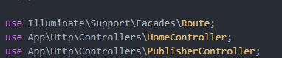

Delete ‘/’ route which refers to welcome blade file and also delete the blade file from resources/views folder

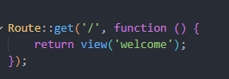

## Home

Create home route by using Route∷get method and in the first argument set it to ‘/’ and for the second argument set it to [HomeController::class, 'index'] which will call the index function in HomeController. Name the route as ‘home’ using ->name at the end.

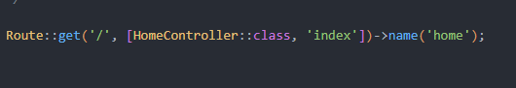

## Book Detail

Create book detail route by using Route∷get method and in the first argument set it to ‘/book/{id}’, id will refer to book id that will be passed by the controller.For the second argument set it to [HomeController::class, 'viewBook'] which will call the viewBook function in HomeController. Name the route as ‘view-boook’ using ->name at the end.



## Category

Create category route by using Route∷get method and in the first argument set it to ‘/category/{category_name}’, category_name will refer to category name that will be passed by the controller.For the second argument set it to [HomeController::class, 'category'] which will call the category function in HomeController. Name the route as ‘category’ using ->name at the end.

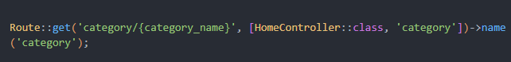

## Publisher

We use Route∷prefix to define a prefix to routes that use the same prefix. Publisher detail and publisher list will use the same prefix, which is ‘publisher’. For example ‘publisher/id’ and ‘publisher/’

Inside the group, create publisher detail route by using Route∷get method and in the first argument set it to ‘/{id}’, id will refer to publisher id that will be passed by the controller.For the second argument set it to [PublisherController::class, 'detail'] which will call the detail function in PublisherController. Name the route as ‘publisher_detail’ using ->name at the end.

Inside the group, create also publisher list route by using Route∷get method and in the first argument set it to ‘/’.For the second argument set it to [PublisherController::class, 'index'] which will call the index function in PublisherController. Name the route as ‘publisher’ using ->name at the end.

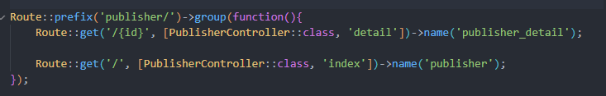

## Contact

Create contact route by using Route∷get method and in the first argument set it to ‘contact’ and for the second argument set it to [HomeController::class, ‘concat’] which will call the contact function in HomeController. Name the route as ‘contact’ using ->name at the end.



## Result

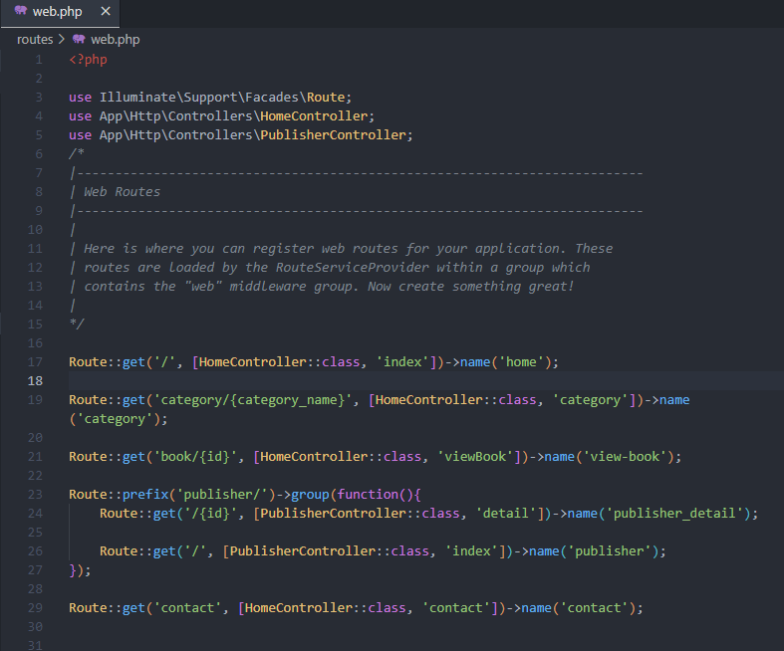

# Create Controllers

## Initialization

Go to terminal and type “php artisan make:controller HomeController” and press enter to create home controller.

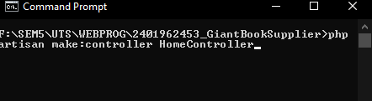

Then type “php artisan make:controller PublisherController” and press enter to create publisher controller.

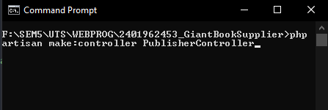

## Home

Import Category and Book model to HomeController in app/Http/Controllers folder

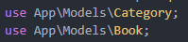

### Index

Inside HomeController class, create a new function called index. Create a new variable called page_name and fill it with “Book List” which will be passed to the view to signify page name. And then create other new variable called books which get all records from Book table. Finally return a view and set the first argument to ‘home.index’ which means the view that will be used is in resources/views/home folder the ‘index.blade.php’. For the second argument, set it to an array which has books and page_name variable (to be passed to view).

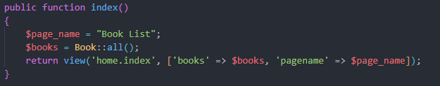

### Category

Inside HomeController class, create a new function called category with name parameter(passed from route).

Create a new variable called category and fill it with “category” which will get category with equal name as name parameter. If category does not exist, redirect to home, otherwise continue to new variable called category_books. Assign category_books to find all books in the category by calling booksCategories() and get(). If there is more than 0 book, go to the next step.

Create a new variable called book_ids and assign an array to it. After that, do for loop to get each book in category books. Find book id by calling book() then first() and get the id, assign it to book_ids array. Create a new variable called books and get book data from Book∷whereIn method by passing id to its argument.

Finally return a view and set the first argument to ‘home.index’ which means the view that will be used is in resources/views/home folder the ‘index.blade.php’. For the second argument, set it to an array which contain books and page_name(category name) variable (to be passed to view).

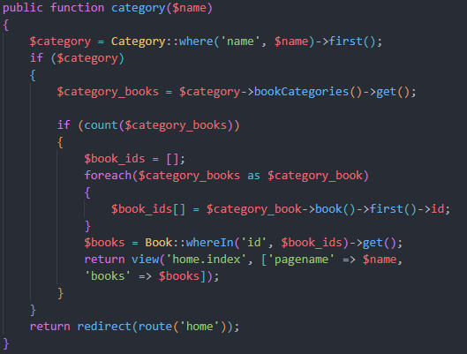

### View Book

Inside HomeController class, create a new function called viewBook with id parameter(passed from route).

Create a new variable called page_name and fill it with “Book Detail” which will be passed to the view to signify page name. And then create other new variable called book which get one book data according to id using find() method. Finally, if book does not exists, redirect to home, otherwise return a view and set the first argument to ‘home.index’ which means the view that will be used is in resources/views/home folder the ‘index.blade.php’. For the second argument, set it to an array which has book and page_name variable (to be passed to view).

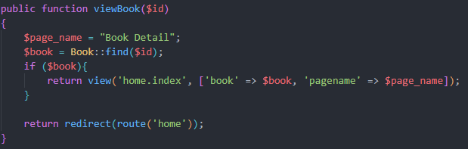

### Contact

Inside HomeController class, create a new function called contact.

We will create several new variable, which are:

* store_address = the address of the store
* store_komplek = the komplek of the store
* store_town = the town of the store
* store_country = the country of the store
* schedule_time = the open schedule of the store
* phone = the phone number of the store
* email = the email of the store
* page_name = page name of contact page

Finally it returns a view with ‘home.contact’ as the first argument and for the second argument, fill an array with new variable we have created earlier.

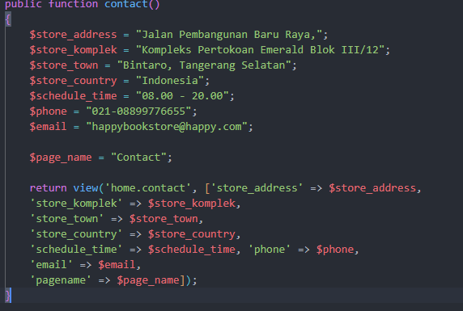

### Result

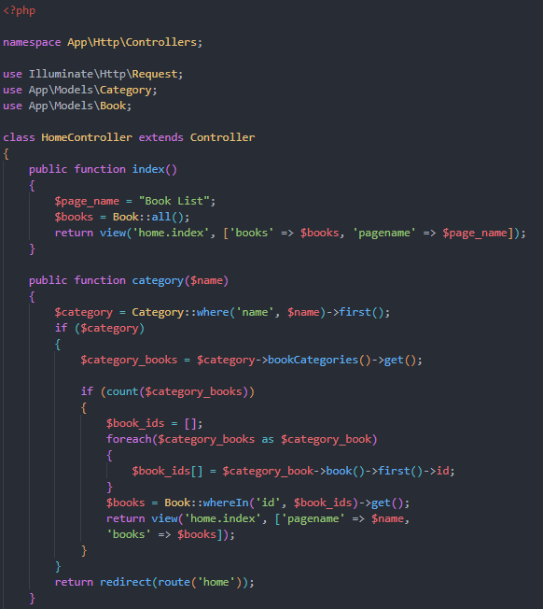

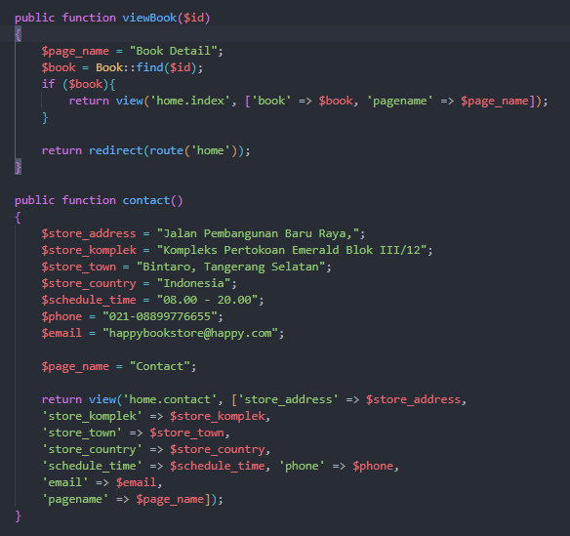

## Publisher

Import Publisher model to PublisherController in app/Http/Controllers folder

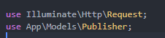

### Index

Inside PublisherController class, create a new function called index. Create a new variable called page_name and fill it with “Publisher” which will be passed to the view to signify page name. And then create other new variable called publishers which get all records from Publisher table. Finally return a view and set the first argument to ‘publisher.index’ which means the view that will be used is in resources/views/publisher folder the ‘index.publisher.php’. For the second argument, set it to an array which has publishers and page_name variable (to be passed to view).

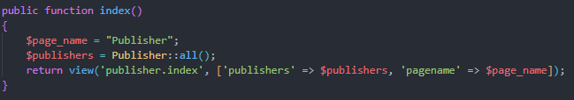

### Publisher Detail

Inside PublisherController class, create a new function called detail with parameter id (passed from route).

Create a new variable called publisher and find a publisher by id using find() method. If publisher does not exist, redirect to publisher route, otherwise create a new variable called books and find books published by publisher we had found earlier by calling books() and get().

Finally return a view and set the first argument to ‘publisher.detail which means the view that will be used is in resources/views/publisher folder the ‘detail.blade.php’. For the second argument, set it to an array which has publisher and books (to be passed to view).

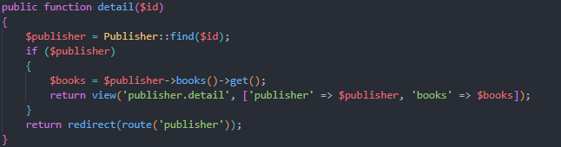

### Result

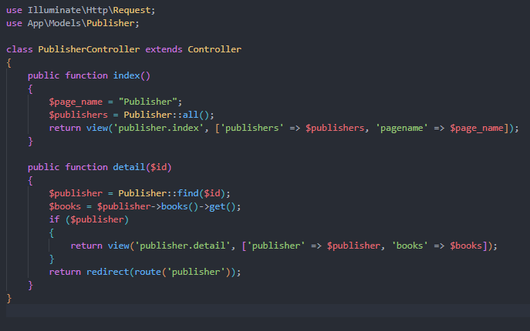

# Create Views

## Initialization

Create several new blade file inside views folder. Those files are:

home Folder

* contact.blade.php
* index.blade.php

layouts folder

* app.blade.php

publisher folder

* index.blade.php
* detail.blade.php

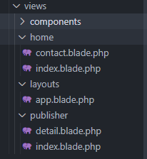

## Import bootstrap

Go to bootstrap website, <https://cdn.jsdelivr.net/npm/bootstrap@5.2.3/dist/js/bootstrap.bundle.min.js/>

<https://cdn.jsdelivr.net/npm/bootstrap@5.2.3/dist/css/bootstrap.min.css/>

Then copy all the css and js code.



Put the css code to public/css/bootstrap.css and js code to public/js/bootstrap.bundle.min.js



Inside the AppServiceProvider file in app/Providers, import Category model.

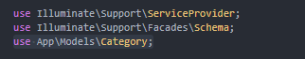

Inside the boot function add code below to reference Category model to app blade file. Pass ‘category_list’ which we get from all method.

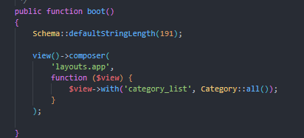

## Layout

Create HTML boilerplate inside app.blade.php we have created earlier.

Change several things in the head section:

* Title to “Giant Book Supplier”
* Import css/bootstrap.css we have created using link and set it as stylesheet
* Follow the code that can be seen below

Add several things in the end of body section

* Import js/bootstrap.bundle.min.js script

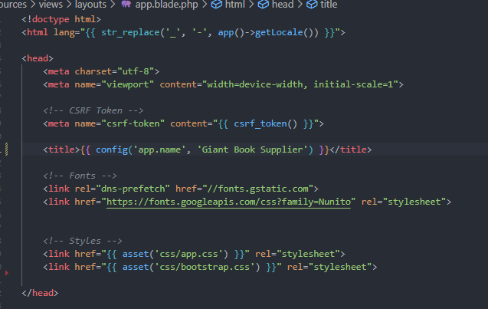

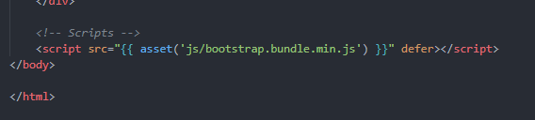

Add several things in the body section

* Add nav, main, and footer
* Add @yield(‘content’) to main so app.blade.php can be the parent view and the child view then can extend from it.

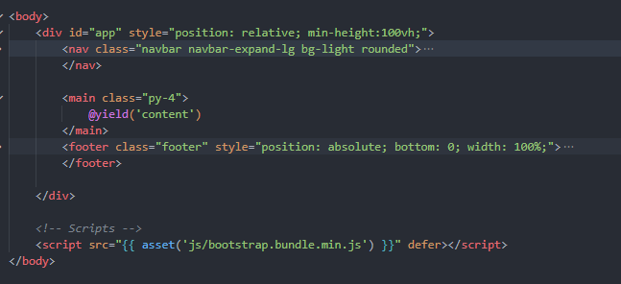

Using bootstrap, add bootstrap class like picture below to div in the footer.

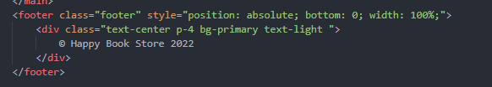

Use navbar from bootstrap website (<https://getbootstrap.com/docs/5.2/components/navbar/>). Then modify it like the second picture below.

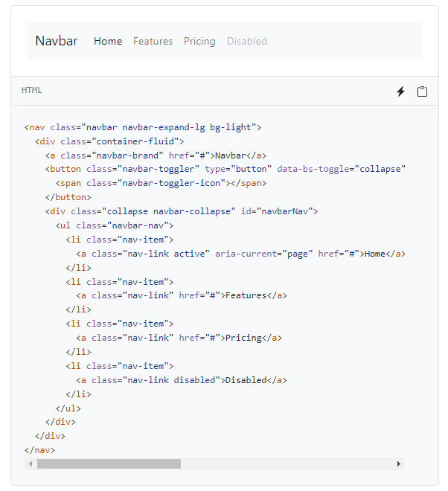

Use @foreach directive to get data passed in from provider (category_list). Get all category name and put it in drop down menu. Each dropdown item has route link to category with category name as the argument.

Set route to each nav item

* Home => route(‘home’)
* Publisher => route(‘publisher’)
* Contact => route(‘contact’)

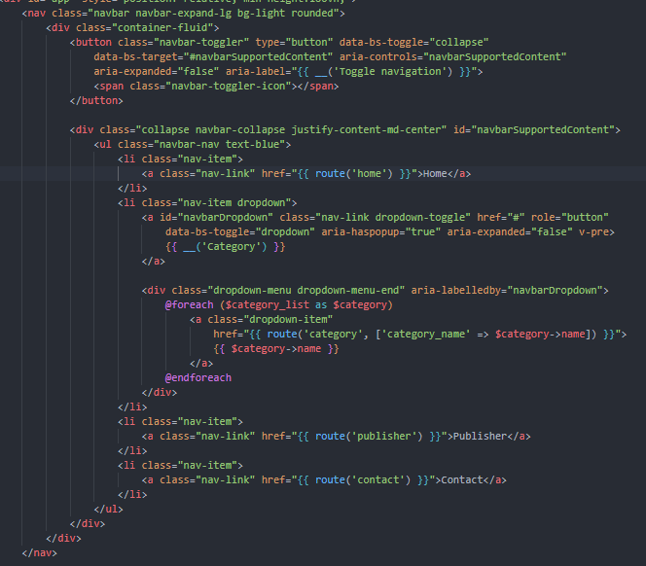

## Components

Go to terminal and type “php artisan make:component Card” and press enter to create card component

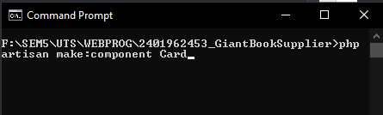

Go to terminal and type “php artisan make:component pageName” and press enter to create page name component

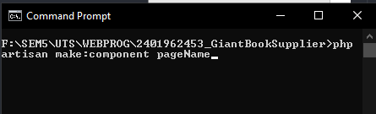

Inside the card.php in app/View/Components, create a new public variable book, and in its construct add 1 parameter (book) and assign the public variable book to book parameter variable.

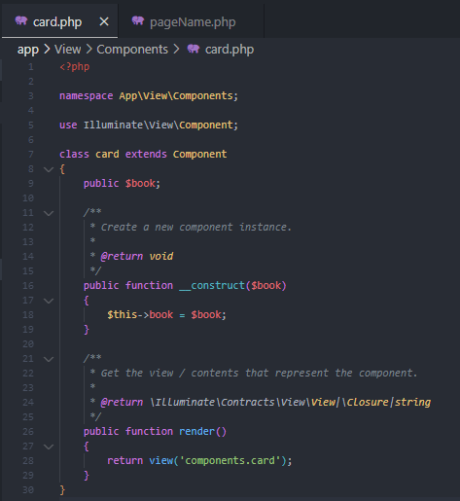

Inside the pageName.php in app/View/Components, create a new public variable page_name, and in its construct add 1 parameter (pagename) and assign the public variable page_name to pagename parameter variable.

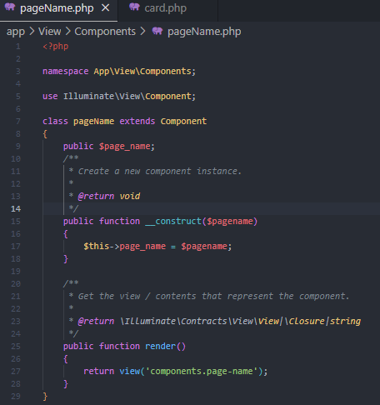

Inside resources/views/components folder, modify the card.blade.php using bootstrap card and follow the code below.

Beside that, inside the src of img tag, type "{{ asset('storage/images/book/' . $book->image) }}" to get image from storage we have created in the first step of this project. Get image string from book which we pass from card.php file earlier. Inside the card body, set title, author from book variable too. In the detail button a tag, put route in the href to ‘view book’ route. And pass the book id. If we click the button, it will go to book detail page.

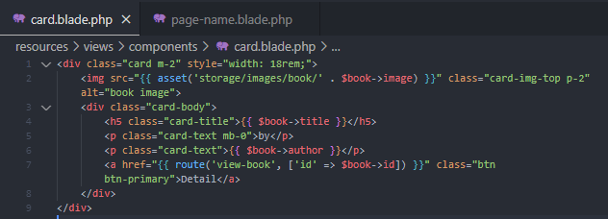

Inside resources/views/components folder, modify the page-name.blade.php like the code below using bootstrap classes. Put page_name variable in h1 tag which we got from pageName.php we created earlier.

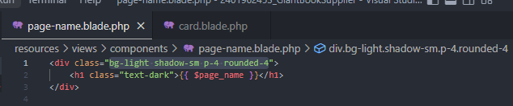

## Page Initialization

Inside home index.blade.php, contact.blade.php, publisher index.php, and detail.blade.php add cde below to extend from layout view we have created earlier in app.blade.php.

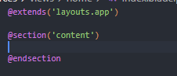

## Home & Category

Inside the content @section in index.blade.php add divs with bootstrap class such as container, cool, card, etc which you can follow like the image below.

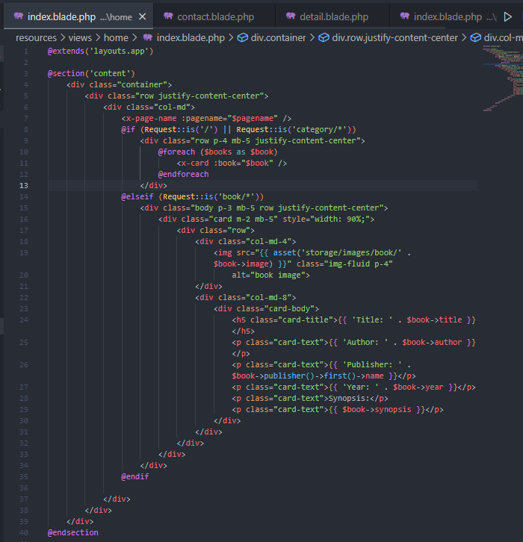



Inside it, I code some @if, @elseif directive. The @if directive function as page changer. If routes request is ‘/’ or ‘category/*’ then it will only render the content of the if directive. This is because home and category uses a similar layout, so I reused it. Just change value ($books and $pagename) that is passed from the controller. Inside this code, it will generate several component card according to books length.

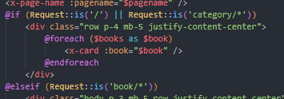

Here we also use two component (page-name and card) we have created earlier, put it in above the if directive. To use component, we need to put ‘x-’ first then the name of the component, and add ‘:’ first to pass an argument to the component.

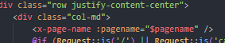

## Book Detail

For the book detail, it still uses the same file as home and category, the index blade file. It will render the book detail when the request route is ‘book/*’

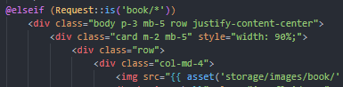

The book detail will render a bootstrap card which has image, title, book, publisher, year, and synopsis. We get the $book variable from the controller. The publisher data we get from publisher function inside book model.

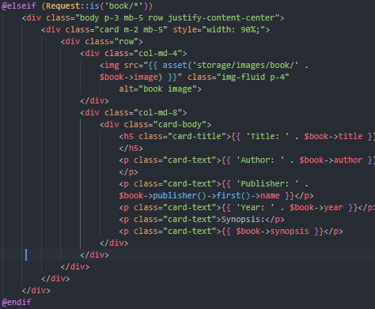

## Contact

In the contact blade file, we also use bootstrap classes such as container, col, body, card, and etc.

Inside the card, we insert book shop image from public folder using url.

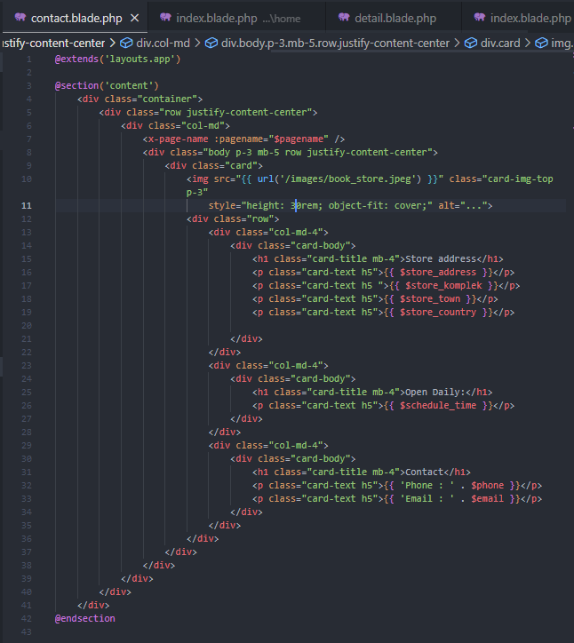



Inside the card body, we use some variable we passed from the controller such as $store_address, $store_komplek, $store_town, $store_country, $schedule_time, $phone, and $email to the card title and card text.

## Publisher List

The Publisher List page is inside publisher/index.blade.php file. It pretty much similar to the index.blade.php file in home/index.blade.php (except the if else directive), it has page name component and card list.

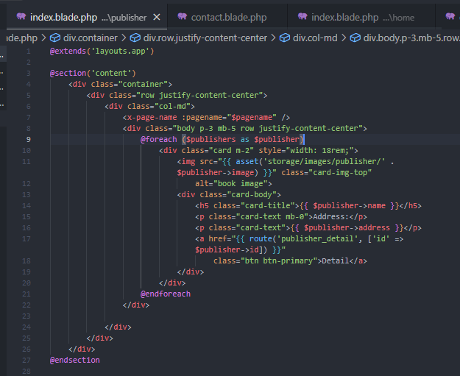

The card is a little different from card we use in the component, it uses the $publisher variable data we got from the controller which has publisher image logo, name, and address. Inside the detail a tag button, the href has route to ‘publisher_detail’ with publisher id as argument, if we click this button, it will go to publisher detail page.

## Publisher Detail

The publisher detail page uses bootstrap class like container, row, bg, text, and etc. In the upper section it will display name, address, phone, and email of the publisher which uses the data from variable $publisher which is passed from the controller. This section uses bg-light, shadow, and rounded bootstrap class to create floating square background.

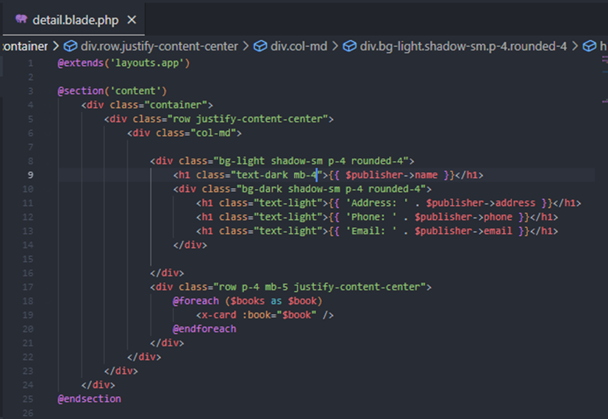

In the lower section, we use @foreach directive to iterate the $books variable and display it as list of card using card component.

# Screenshot

## Home

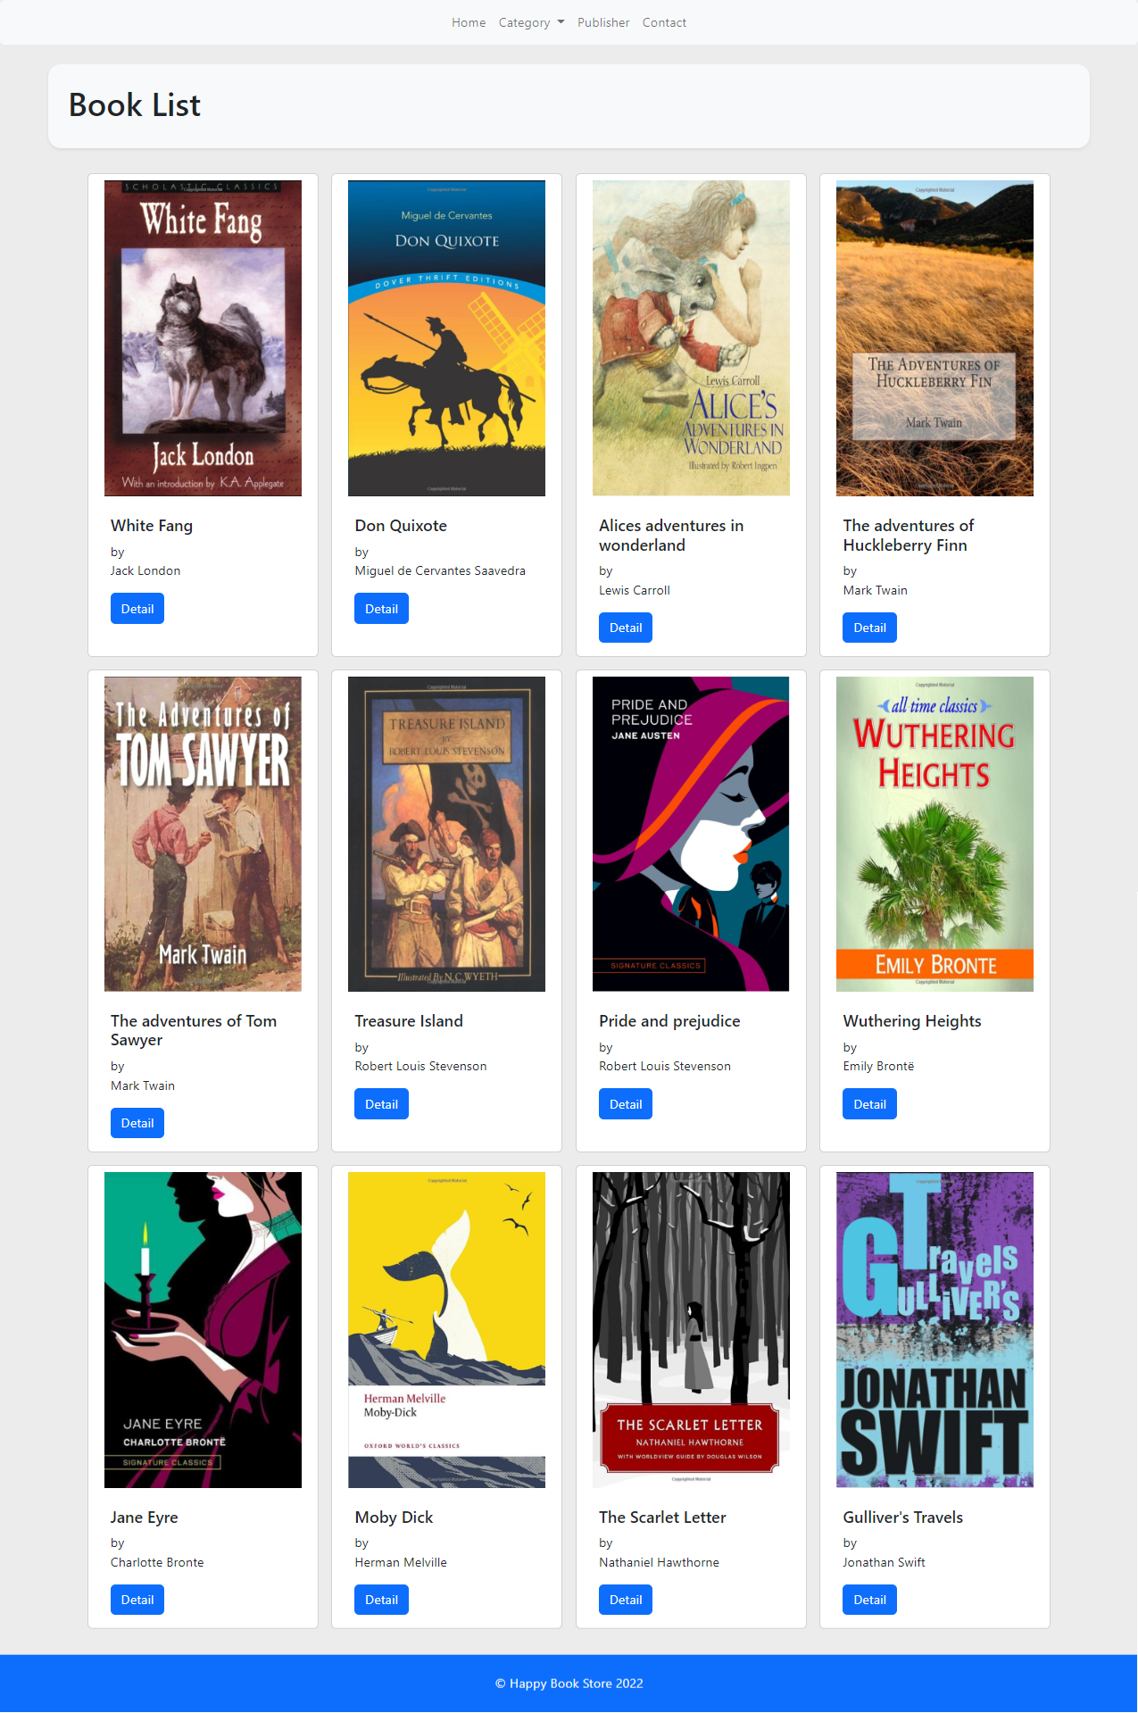

## Category

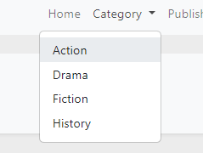

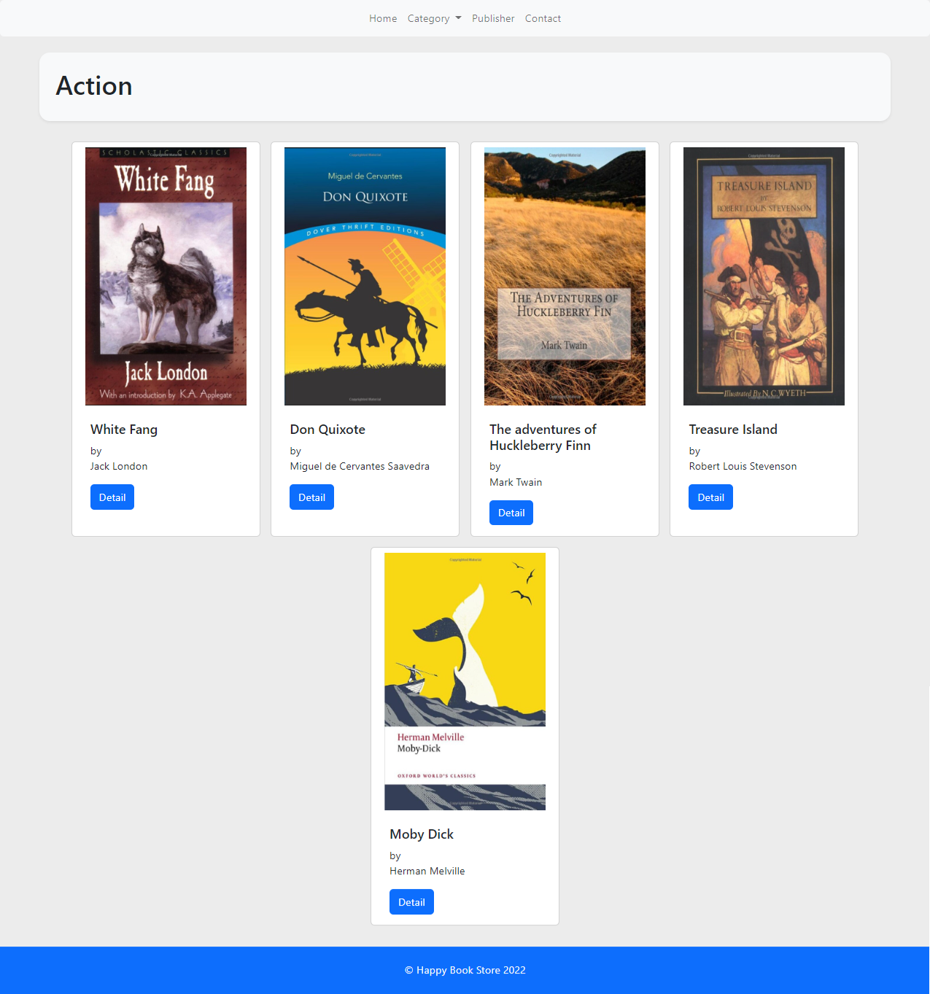

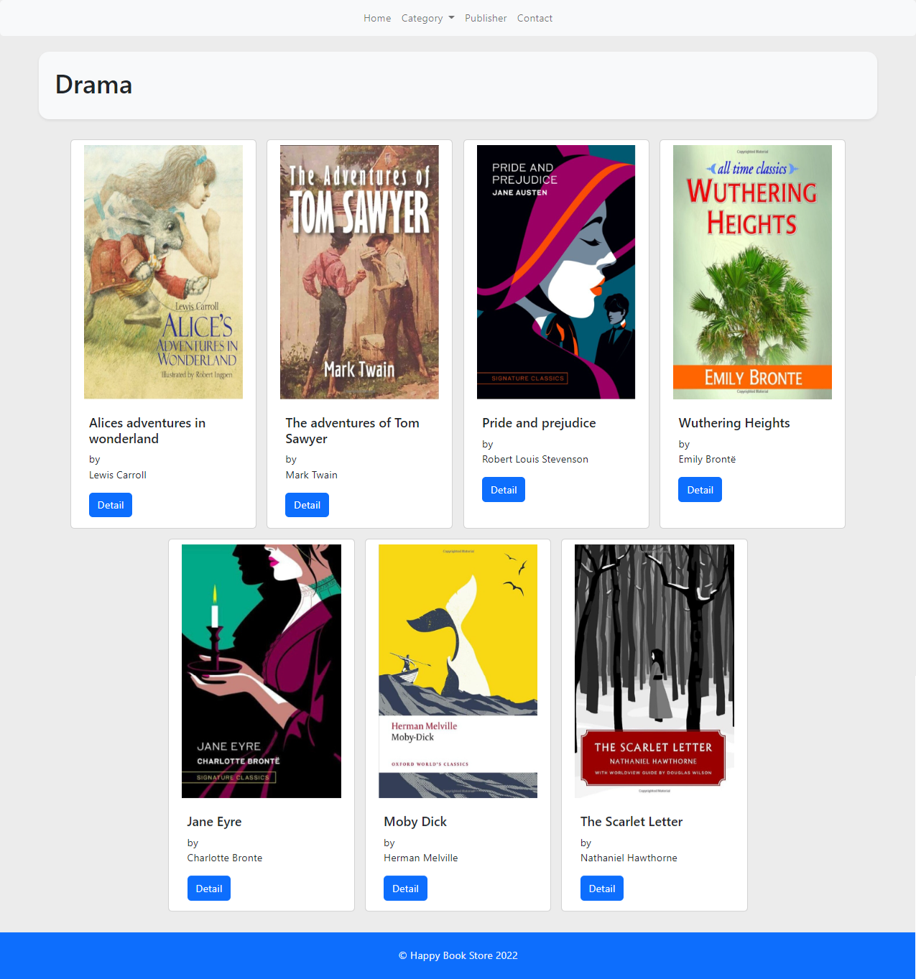

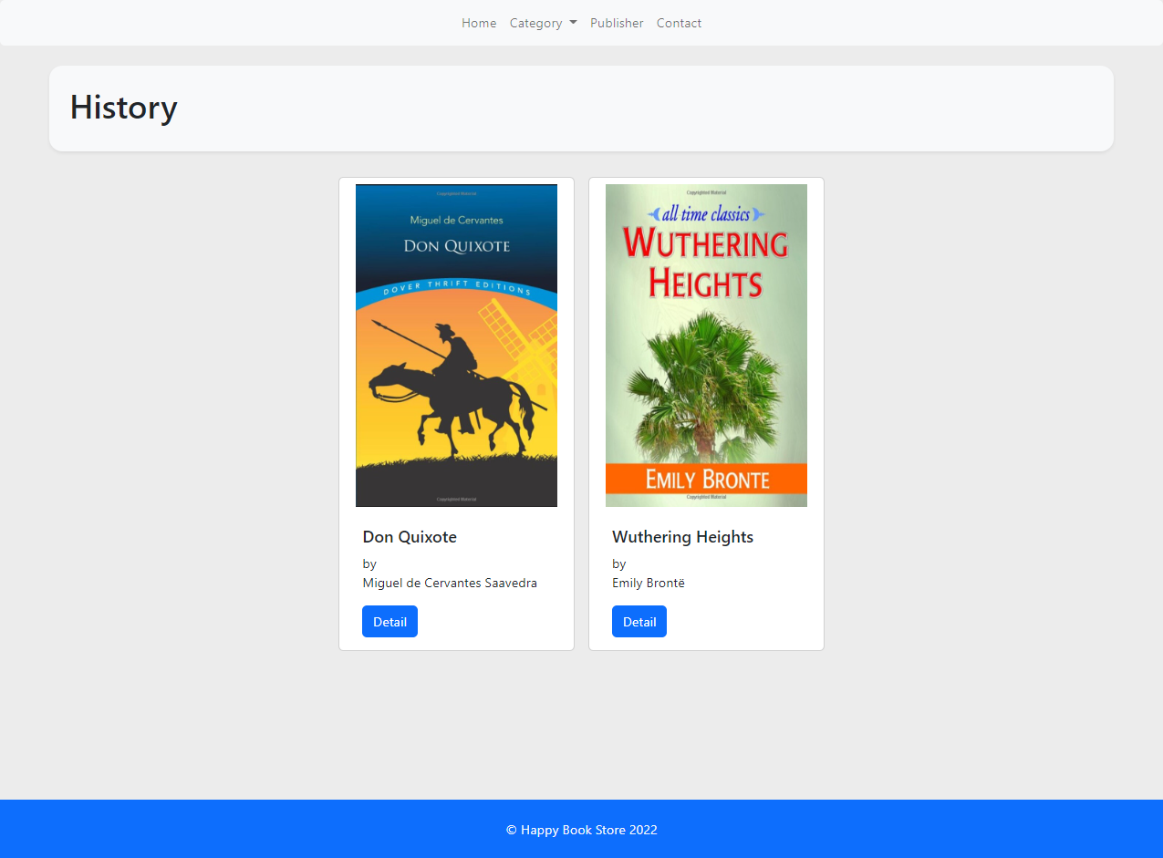

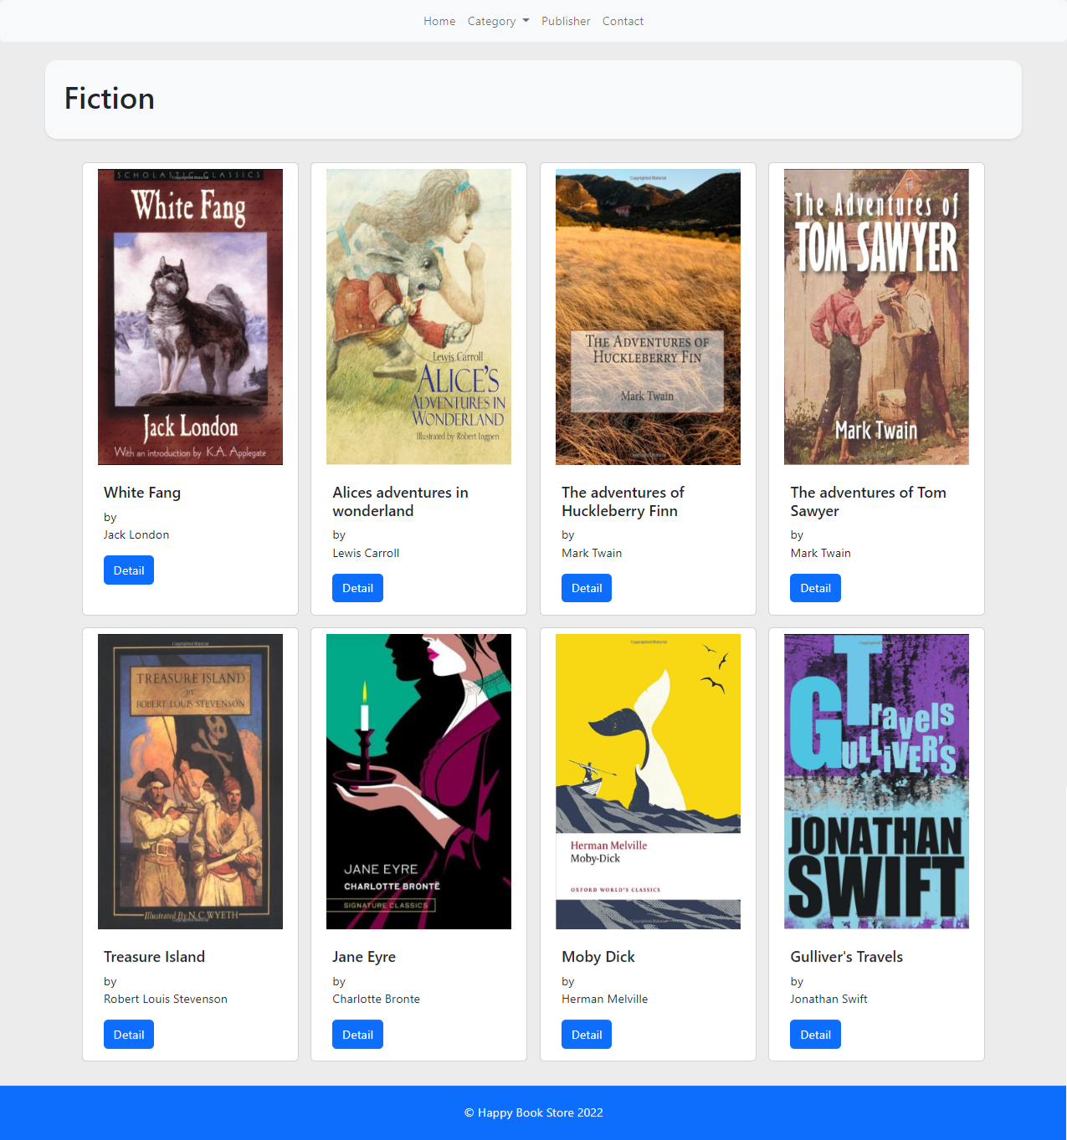

## Book Detail

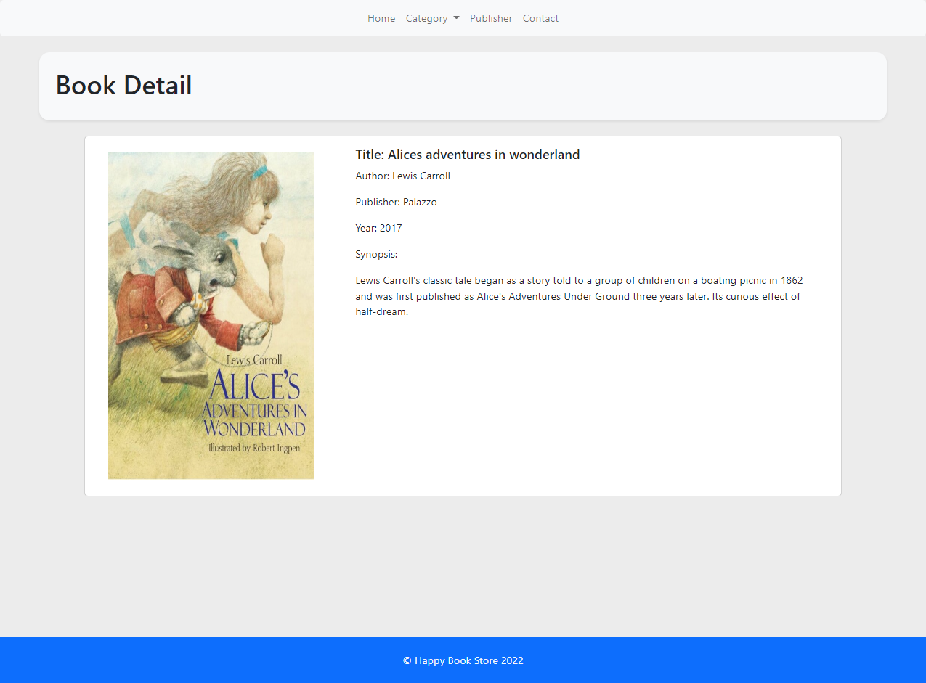

## Publisher List

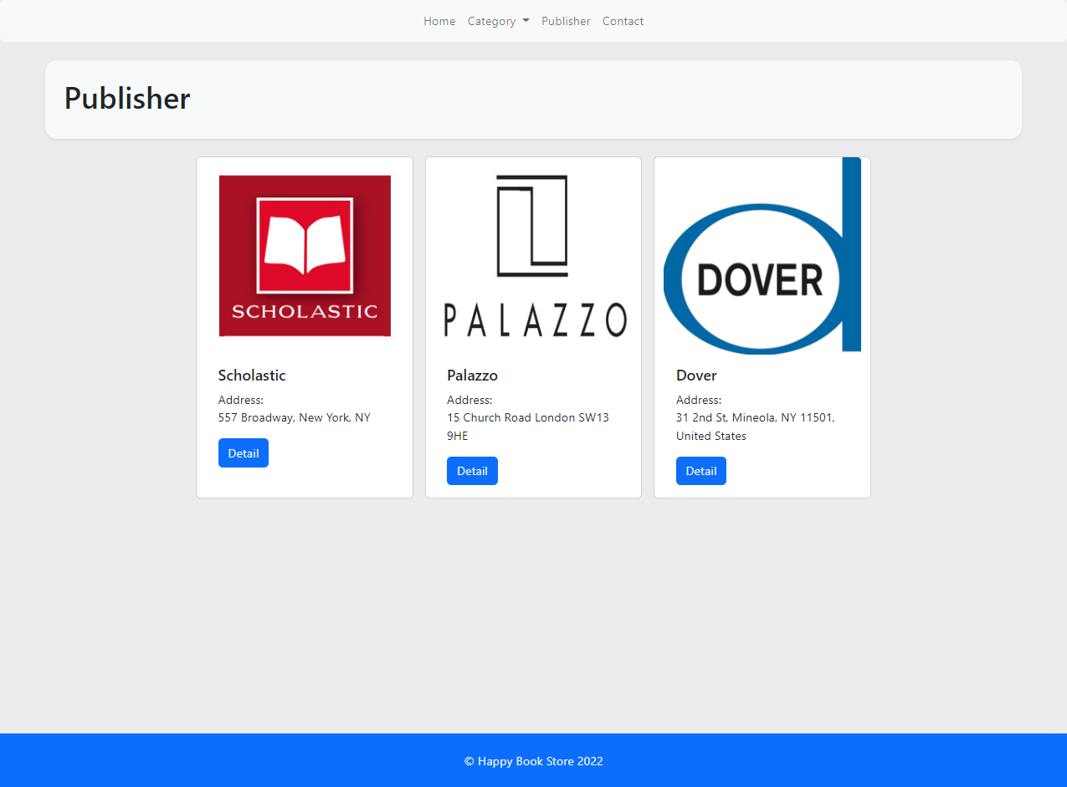

## Publisher Detail

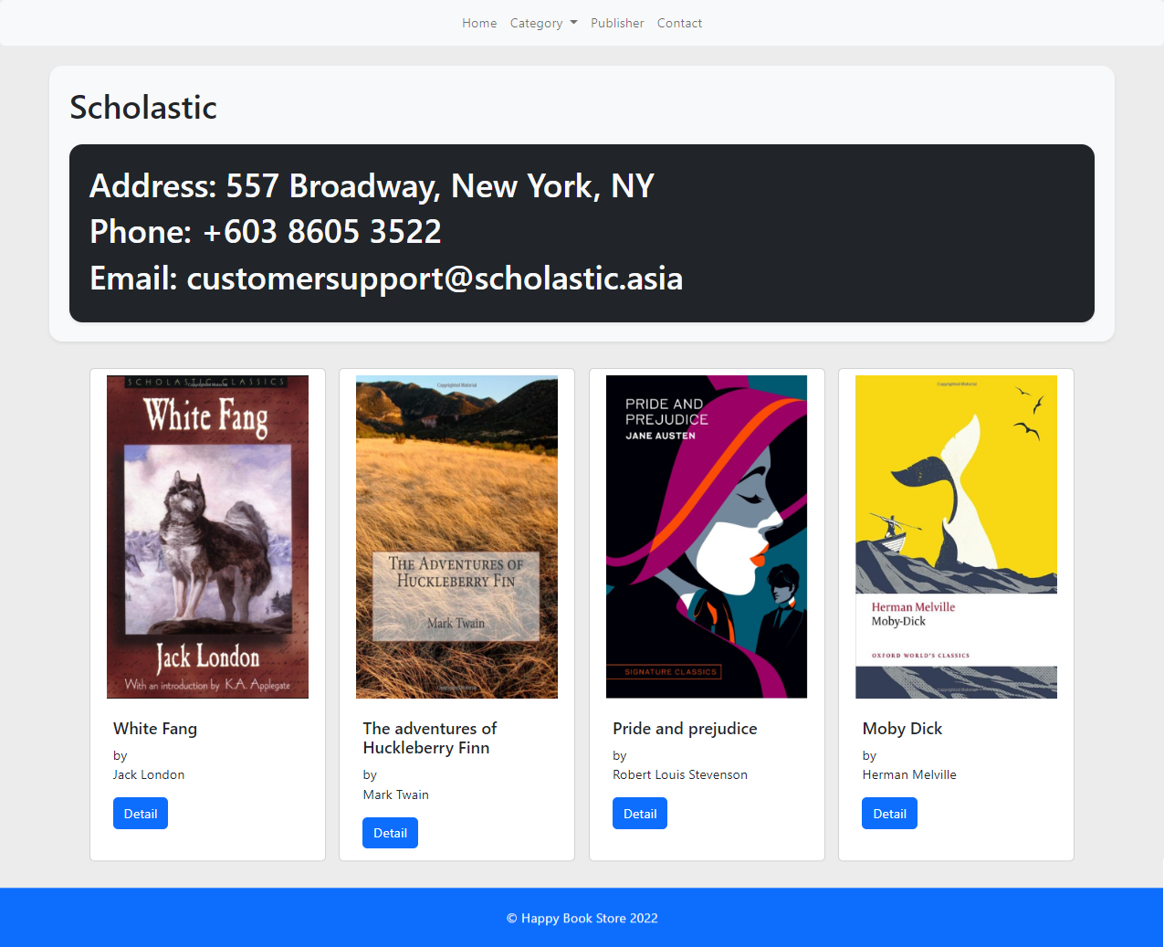

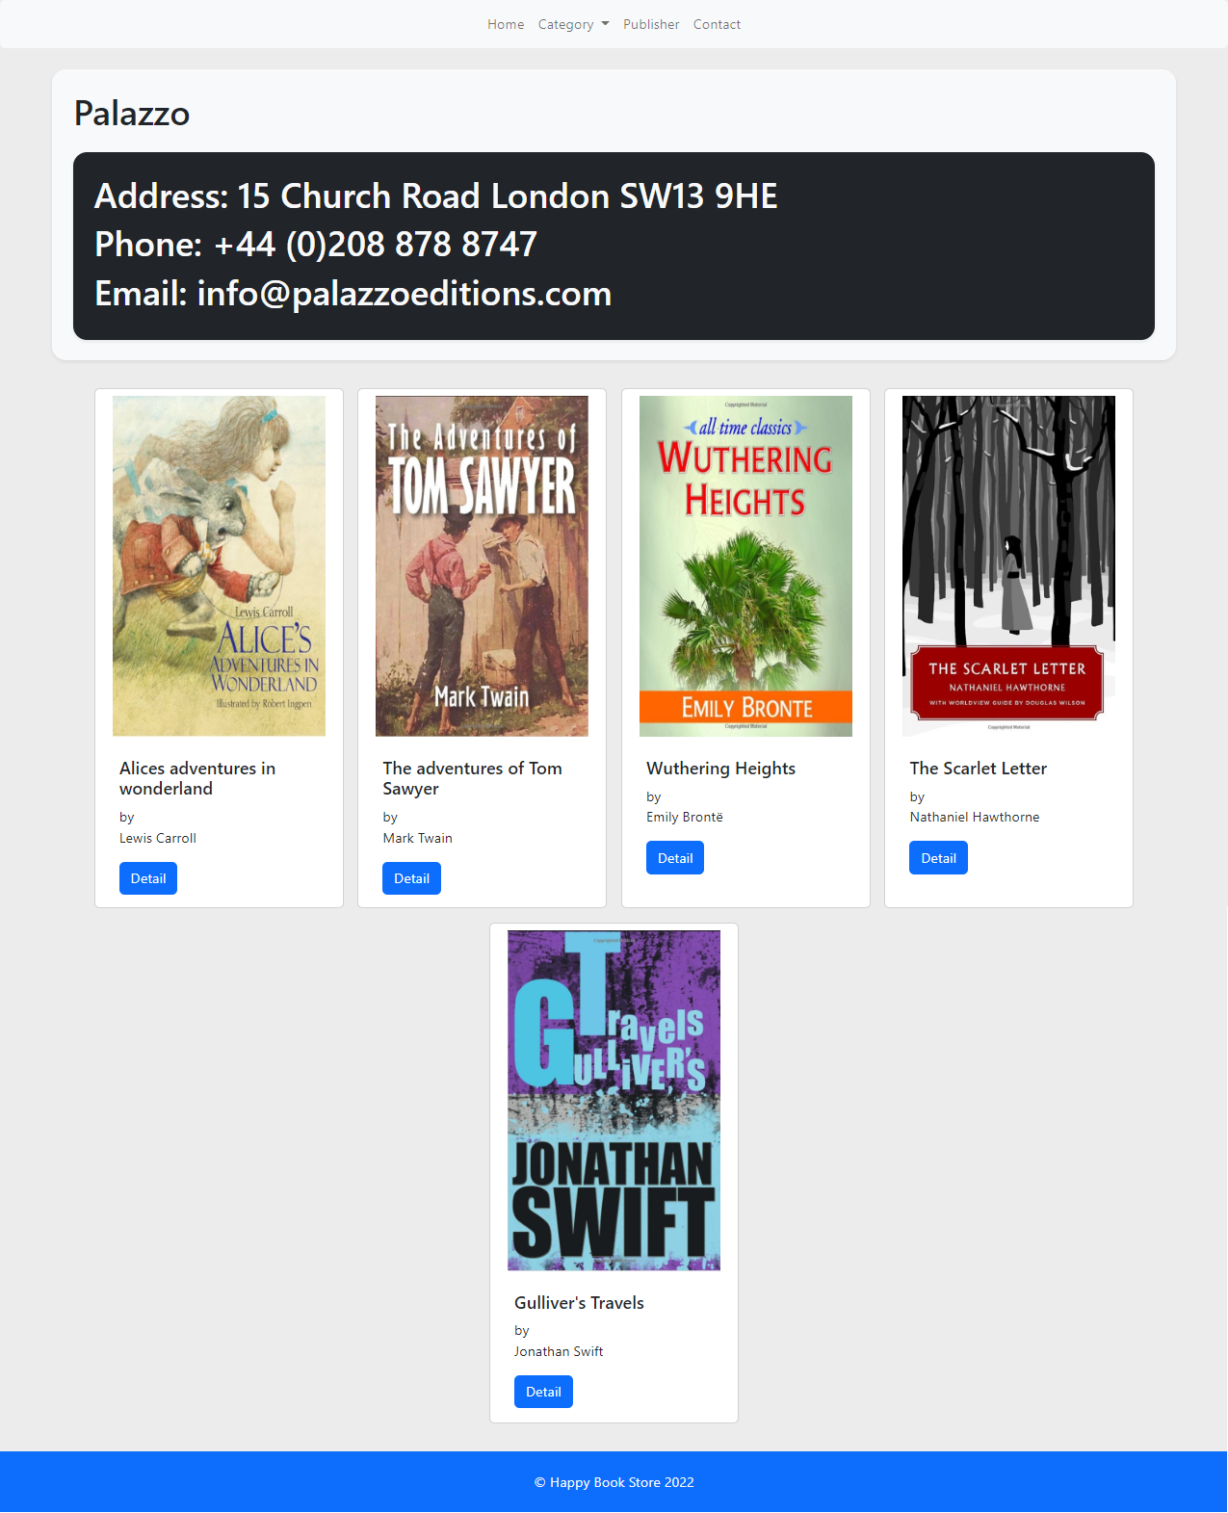

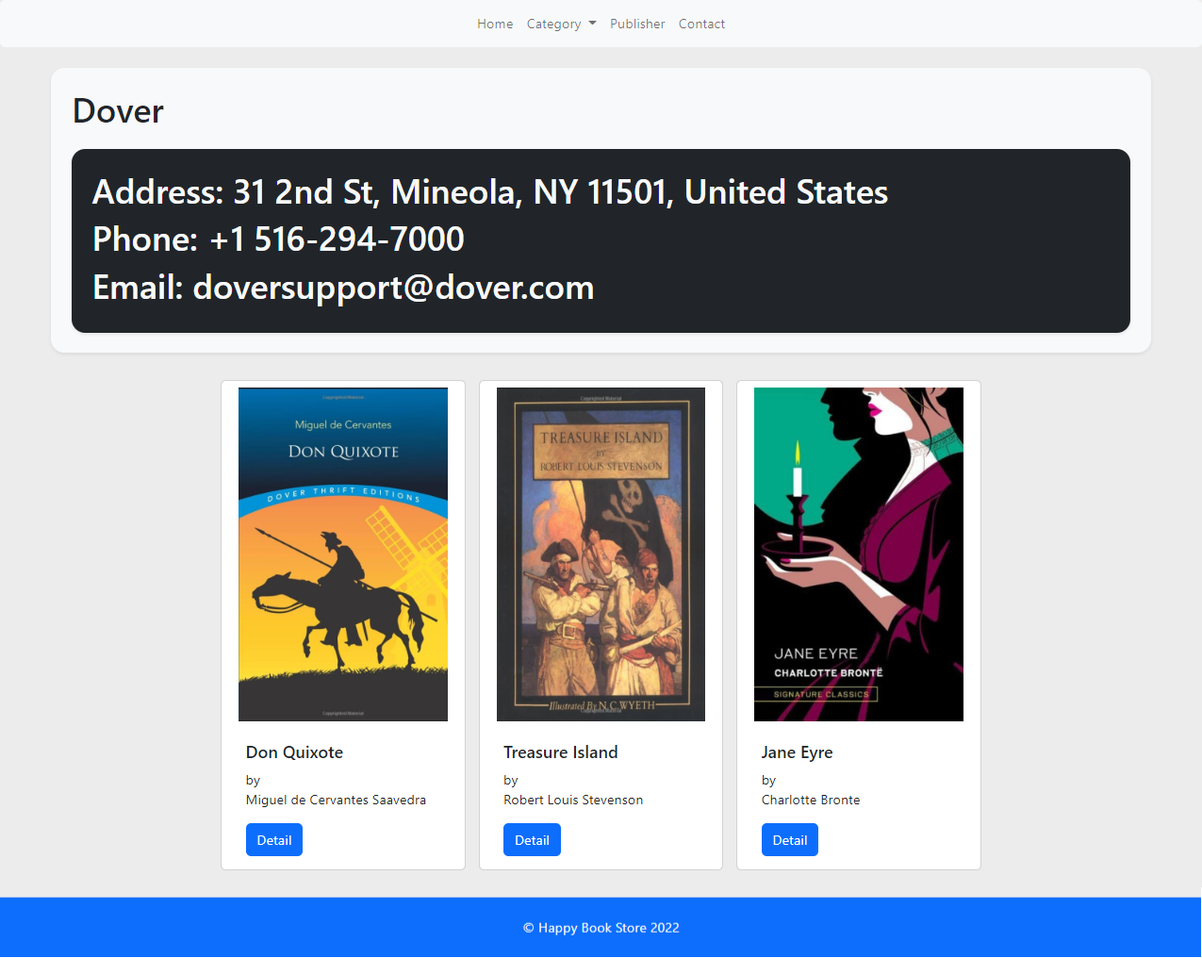

## Contact

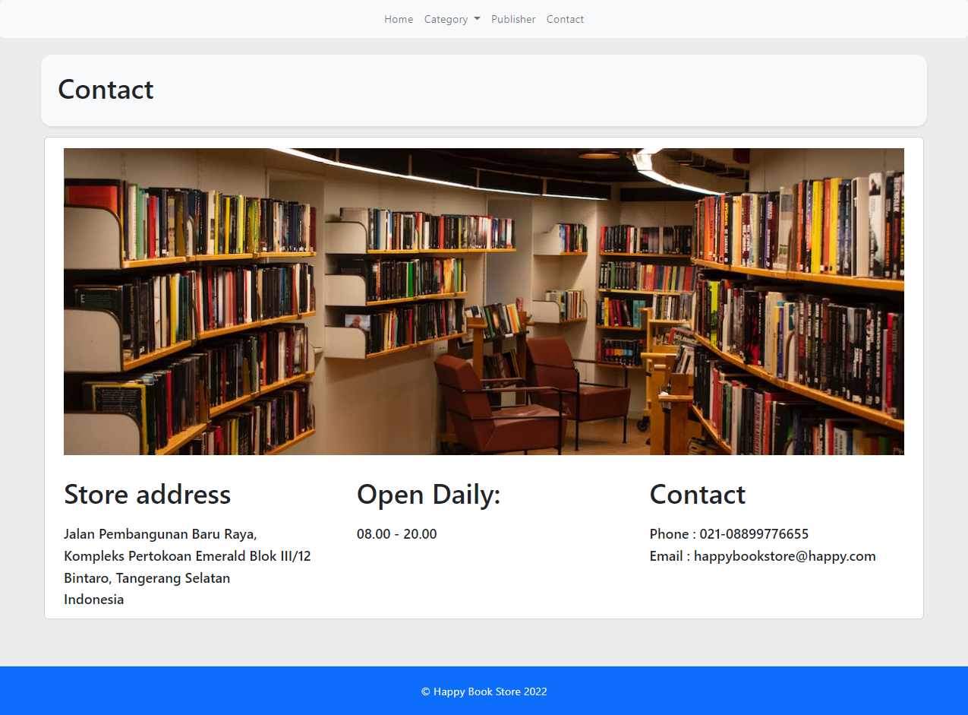

# Reference

## Picture and Text

1. https://creativekidstales.com.au/publishers-in-focus/scholastic/
2. https://www.publishersweekly.com/pw/by-topic/industry-news/publisher-news/article/81711-dover-cutting-jobs-as-part-of-restructuring.html
3. https://www.palazzoeditions.com/
4. https://www.worldcat.org/title/1267387253
5. https://www.worldcat.org/title/1306278427
6. https://www.worldcat.org/title/1128887231
7. https://www.worldcat.org/title/24065589
8. https://www.worldcat.org/title/1023201734
9. https://www.worldcat.org/title/1299245898
10. https://www.worldcat.org/title/1096216531
11. https://www.worldcat.org/title/1309904636
12. https://www.worldcat.org/title/7551075
13. https://www.worldcat.org/title/45749411
14. https://www.worldcat.org/title/74459734
15. https://www.worldcat.org/title/1020679308

## Documentation

1. https://laravel.com/docs/8.x/
2. https://getbootstrap.com/
3. https://getbootstrap.com/docs/5.2/components/navbar/
4. https://getbootstrap.com/docs/5.0/components/card/
5. https://cdn.jsdelivr.net/npm/bootstrap@5.2.3/dist/js/bootstrap.bundle.min.js/
6. https://cdn.jsdelivr.net/npm/bootstrap@5.2.3/dist/css/bootstrap.min.css/